Spatio-Temporal Landslide Susceptibility Mapping using Random Forest and Explainable AI (SHAP) in Gilgit District, Pakistan (2018–2025)
By
Ishmal Imran (22011508-002)
Qurat-ul-ain Khalid (22011508-022)
Sana Sabir (22011508-063)
Amna Mehdi Khan (22011508-024)
1) DEGREE PROGRAM: …………………….…………………………........ BS
2) DEPARTMENT: ……………….……...…….……………….. GEOGRAPHY
3) FACULTY NAME: ………………………........... FACULTY OF SCIENCES
4) CAMPUS NAME: ……………………………………............ HAFIZ HAYAT
5) SUPERVISOR NAME: ………………….…………… Mam Saira Munawar
6) DEGREE EMPLOYMENT SEMESTER ………………....…….. FALL2022
7) FREEZED OR MISSED SEMESTER (IF ANY) …….………………..…N/A
8) DATE OF SYNOPSIS SUBMISSION TO THE DEPARTMENT ….……….
9) DATE OF APPROVAL FROM DRRC ………………………………………...
10) Scholar’s Signature……………………………………………………………...
11) Supervisor Signature……………………………………………………………
12) Chairperson/Head Signature …………………………………………………..
13) Convener Faculty Board Signature ……………………………………….......
14) Date of Approval by ASRB……………………………………………………..

__________________________________________________________
Table of Contents

Contents Page

ABSTRACT 3
INTRODUCTION 4
Problem Statement and Significance 5
OBJECTIVES 5
RESEARCH QUESTIONS 5
LITERATURE REVIEW 5
Research Gap 7
Study Area 7
METHODOLOGY 7
Landslide Susceptibility Mapping and Spatio-Temporal Analysis 10
References 12

ABSTRACT
Landslides are one of the most destructive natural hazards in Gilgit District, northern Pakistan, driven by steep terrain, active tectonics, and intense rainfall events. Although several studies have applied machine learning for landslide susceptibility mapping, most rely on static models and provide little explanation of why landslides occur in specific locations. This study aims to develop a simplified yet robust spatio-temporal landslide susceptibility framework for Gilgit District covering the period 2018–2025 using a single ensemble machine learning model and Explainable Artificial Intelligence (XAI).
Multi-source geospatial data will be integrated with key landslide conditioning factors: elevation, slope, rainfall, land-use/land-cover, NDVI, and distance to roads. A time-stamped landslide inventory will be prepared using NASA COOLR, the Global Fatal Landslide Database, and Sentinel-2 imagery. Random Forest (RF) will be used as the primary prediction model due to its high accuracy and stability in mountainous environments. To overcome the black-box nature of machine learning, SHapley Additive exPlanations (SHAP) will be applied to explain model predictions and identify the most influential landslide-triggering factors.
Model performance will be evaluated using ROC-AUC, Accuracy, F1-Score. Spatio-temporal analysis will be performed for three periods (2018–2020, 2021–2023, 2024–2025) to analyze changes in landslide susceptibility over time. The final outputs will include interpretable susceptibility maps and factor importance analysis to support disaster risk reduction and infrastructure planning in Gilgit District.

INTRODUCTION
Landslides are the downslope movement of rock, soil, and debris under the influence of gravity and are among the most widespread geomorphological hazards in mountainous regions. They occur due to a complex interaction of natural factors such as steep slopes, active tectonics, intense rainfall, and earthquakes, together with human activities including road construction, deforestation, and unplanned urban expansion. Recent global assessments show that the Hindu Kush–Himalayan (HKH) region is one of the world’s most landslide-prone areas and contributes a large proportion of global landslide fatalities (Akosah et al., 2024; Guria et al., 2025).
Gilgit District in northern Pakistan is particularly vulnerable because it lies within the active collision zone of the Indian and Eurasian plates. The terrain is extremely rugged, with elevations ranging from about 1,500 m in the valleys to more than 7,000 m in the surrounding peaks, and is strongly controlled by major tectonic structures such as the Main Karakoram Thrust (MKT). Previous studies have shown that the Karakoram Highway (KKH) corridor is highly unstable due to fractured lithology, steep slopes, and seasonal monsoon rainfall (Hussain et al., 2021; Shahzad et al., 2024). However, landslide risk is not limited to the highway corridor; remote valleys and growing settlements are increasingly exposed due to snowmelt processes, land-use change, and expanding infrastructure, highlighting the need for a district-wide assessment.
Traditionally, landslide susceptibility mapping relied on heuristic and simple statistical approaches. Although useful, these methods are often static and struggle to represent the complex and non-linear relationships that control landslide occurrence in high-mountain environments. The introduction of machine learning has significantly improved landslide prediction by enabling models to learn these complex relationships from data. Among these, Random Forest (RF) has proven to be one of the most reliable and robust algorithms for mountainous terrain because it handles non-linear interactions, mixed data types, and noisy datasets effectively (Abbas et al., 2023; Kunwar et al., 2025).
Despite these advances, most studies in Gilgit-Baltistan still rely on static susceptibility maps that ignore temporal variation. Landslide susceptibility is not constant; it changes over time due to variations in rainfall, vegetation cover, and human disturbance. Recent research emphasizes that incorporating a spatio-temporal perspective provides more realistic and useful results for disaster risk management (Khaliq et al., 2023; Guria et al., 2025). Therefore, this study analyzes landslide susceptibility for the period 2018–2025, allowing the identification of how landslide patterns have evolved in response to climatic variability and infrastructure development.
Another major limitation of current machine learning studies is the “black-box” nature of the models, which makes it difficult for decision-makers to understand why a location is classified as high risk. This study addresses this gap by integrating Explainable Artificial Intelligence (XAI) using the SHapley Additive exPlanations (SHAP) framework. SHAP explains how each conditioning factor contributes to the model’s prediction, transforming susceptibility maps into transparent and interpretable tools that clearly show whether slope, rainfall, lithology, or proximity to roads are the main drivers of landslide risk (Pradhan et al., 2023; Inan & Rahman, 2023).

Problem Statement and Significance
At present, Gilgit District lacks a comprehensive, interpretable, and time-dependent landslide susceptibility framework. Existing studies mainly focus on short road corridors such as the KKH and provide static maps that are difficult to interpret for practical decision-making. As a result, off-road communities and expanding settlements remain highly vulnerable. This research aims to develop a spatio-temporal, Random Forest-based, and explainable landslide susceptibility model for Gilgit District (2018–2025) using a limited but strong set of conditioning factors. The results will provide an accurate and transparent decision-support tool for the Gilgit-Baltistan Disaster Management Authority (GBDMA) to improve disaster preparedness, guide infrastructure planning, and support sustainable land-use management in this highly fragile mountainous environment.

OBJECTIVES
The main objectives of this study are:
- To develop a time-stamped landslide inventory for Gilgit District from 2018 to 2025.
- To prepare and analyze key landslide conditioning factors using Remote Sensing and GIS techniques.
- To generate spatio-temporal landslide susceptibility maps using the Random Forest model.
- To explain model predictions using SHAP to identify the most influential landslide-triggering factors.

RESEARCH QUESTIONS
- How do key topographic, geological, environmental, and anthropogenic factors influence the spatial distribution of landslide susceptibility in Gilgit District?
- How has landslide susceptibility in Gilgit District changed over the period 2018–2025 due to dynamic factors such as rainfall variability, land-use change, and infrastructure development?
- How effectively does the Random Forest machine learning model predict landslide susceptibility in the rugged terrain of Gilgit District?
- How can Explainable Artificial Intelligence (XAI) using SHapley Additive exPlanations (SHAP) improve the interpretability of the Random Forest model and identify key landslide-triggering factors at local scales?

LITERATURE REVIEW
Landslides are among the most destructive natural hazards in mountainous environments, particularly within tectonically active regions such as the Himalayan–Karakoram–Hindu Kush (HKH) system. In recent decades, landslide risk in these regions has intensified due to rapid population growth, expanding transportation networks, and climate-induced extreme rainfall events. Consequently, landslide susceptibility mapping (LSM) has become a critical tool for disaster risk reduction, land-use planning, and the protection of strategic infrastructure. Over the past two decades, LSM techniques have evolved from qualitative and statistical approaches to advanced machine learning (ML) methods, largely driven by improvements in remote sensing data availability and computational capability.
Recent studies consistently show that ML models outperform traditional statistical and heuristic methods because they can capture complex, non-linear relationships between landslide occurrences and multiple conditioning factors. Abbas et al. (2023) investigated landslide susceptibility along the Karakoram Highway (KKH) using ensemble ML models and demonstrated that Random Forest (RF) achieved high predictive accuracy in complex mountainous terrain. Their study highlighted the suitability of RF for regions with heterogeneous topography and emphasized its robustness when working with multi-source geospatial datasets. This supports the selection of RF as an effective model for landslide susceptibility mapping in Gilgit District.
Similarly, Hussain et al. (2022) applied RF and other ML models in Muzaffarabad District, Pakistan, and reported that RF outperformed alternative classifiers. Elevation, slope, and rainfall were identified as the most influential factors, confirming their dominant role in landslide occurrence in the northwestern Himalaya.
Shahzad et al. further compared several ML algorithms in northern Pakistan and found that tree-based models such as RF consistently produced reliable results in rugged mountainous landscapes. These studies collectively demonstrate that RF is a suitable and stable model for landslide susceptibility mapping in tectonically active regions comparable to Gilgit District.
Beyond Pakistan, Kunwar et al. (2025) assessed ML-based landslide susceptibility in the Indian Himalayas and reported strong performance of tree-based ensemble models under complex terrain and monsoon-driven rainfall conditions. Their findings reinforce the transferability of RF-based approaches to Himalayan environments, supporting its application in the Gilgit region where similar geomorphic and climatic conditions prevail.
While many early ML studies focused on static landslide susceptibility maps, recent research emphasizes the importance of incorporating temporal variability. Khaliq et al. (2023) developed a spatio-temporal ML framework and showed that landslide susceptibility changes significantly over time due to rainfall variability, land-use change, and infrastructure expansion. Guria et al. (2025) extended this approach across the Hindu Kush Himalayan region and demonstrated that time-dependent modeling improves prediction robustness and better reflects evolving landslide patterns. These studies highlight the necessity of adopting a spatio-temporal framework rather than a single-year static model, particularly in climate-sensitive mountain regions such as Gilgit-Baltistan.
Transportation corridors remain one of the most landslide-prone environments in mountainous regions. Hussain et al. (2021) validated RF-based susceptibility maps along the Karakoram Highway using PS-InSAR deformation measurements and confirmed that highly susceptible zones corresponded with active ground movement. This demonstrates the practical value of RF-based susceptibility mapping for infrastructure risk management and supports extending such analyses beyond the highway corridor to a district-wide scale, as proposed in this study.
Despite high predictive accuracy, ML models are often criticized for their “black-box” nature, which limits their practical adoption by decision-makers. To address this limitation, Pradhan et al. (2023) introduced Explainable Artificial Intelligence (XAI) for landslide susceptibility mapping using SHapley Additive exPlanations (SHAP). Their results showed that SHAP effectively reveals the contribution of each conditioning factor and improves the transparency of ML predictions. An et al. further demonstrated that SHAP enhances both interpretability and model reliability in complex terrains, while Inan and Rahman (2023) showed that TreeSHAP can identify the most influential factors and reduce model complexity without sacrificing accuracy. These studies establish SHAP as a powerful tool for transforming RF models from black-box predictors into interpretable decision-support systems.

Research Gap
Although significant progress has been made in ML-based landslide susceptibility mapping, important gaps remain. Most studies in Gilgit-Baltistan focus on limited areas such as the Karakoram Highway and rely on static models that do not account for temporal change. Moreover, explainable AI techniques are rarely integrated at the district scale. Therefore, a clear need exists for a spatio-temporal, interpretable landslide susceptibility framework using Random Forest and SHAP for Gilgit District. This study addresses this gap by combining time-dependent remote sensing data (2018–2025), a robust ML model, and explainable AI to support disaster risk reduction, land-use planning, and infrastructure resilience.

Study Area
Gilgit District, the administrative center of Gilgit-Baltistan in northern Pakistan, is located at approximately 35°55′ N latitude and 74°18′ E longitude and lies at the junction of the Karakoram and Hindu Kush mountain ranges. The district is characterized by extremely rugged terrain, with elevations ranging from about 1,450 m in valley areas to over 7,000 m in surrounding peaks, making it highly susceptible to slope instability. The region is drained mainly by the Gilgit River and the Hunza River, whose active erosion further weakens valley slopes. Geologically, Gilgit lies within the active Indian–Eurasian plate collision zone and is influenced by major tectonic structures such as the Main Karakoram Thrust (MKT), resulting in frequent seismic activity and fractured lithology. The climate is predominantly cold desert, with intense localized rainfall during the monsoon season and rapid snowmelt in spring acting as major landslide triggers. In recent years (2016–2025), increased anthropogenic activities, particularly the expansion of the Karakoram Highway and urban development, have further disturbed natural slopes, increasing landslide susceptibility across the district.
.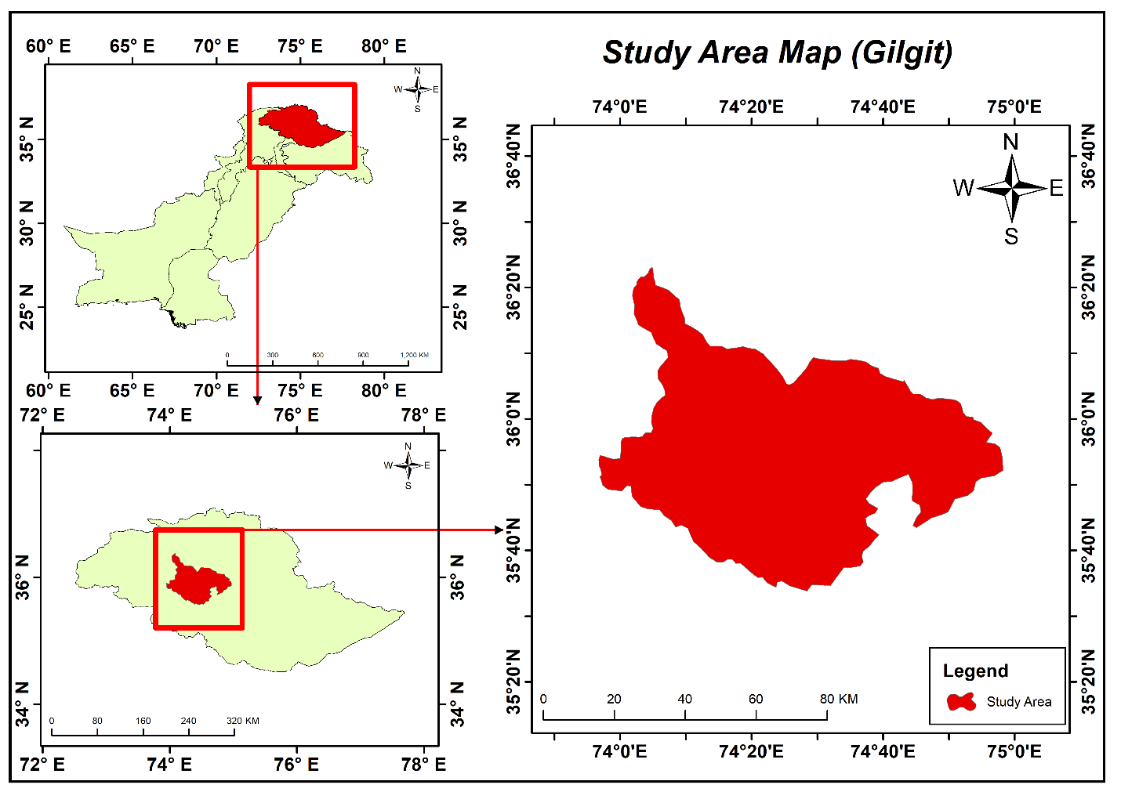.

METHODOLOGY
This study adopts an integrated Remote Sensing, GIS, and Machine Learning framework to map spatio-temporal landslide susceptibility in Gilgit District for the period 2018–2025. The workflow consists of landslide inventory preparation, selection and processing of conditioning factors, model development using Random Forest, validation, explainable AI analysis using SHAP, and generation of susceptibility maps.

Landslide Inventory Preparation (2018–2025)
A time-stamped landslide inventory will be developed to represent historical landslide occurrences in Gilgit District. Landslide locations will be compiled from:
- NASA Cooperative Open Online Landslide Repository (COOLR)
- Global Fatal Landslide Database (GFLD)
- Visual interpretation of Google Earth and Sentinel-2 imagery
Each landslide will be assigned a year of occurrence to enable spatio-temporal analysis. The inventory will be divided into training and testing datasets for model development and validation.
Selection of Landslide Conditioning Factors
To keep the study practical and robust, nine key conditioning factors will be used based on literature and data availability:
- Slope
- Elevation
- Rainfall intensity (GPM IMERG)
- Land Use / Land Cover (LULC)
- NDVI
- Distance to Rivers
- Distance to Roads
- Lithology
- Distance to Faults
These factors represent the most influential topographic, hydrological, environmental, geological, and anthropogenic controls on landslide occurrence in Himalayan terrain.
Data Pre-processing
All datasets will be standardized to a common coordinate system and spatial resolution. The SRTM 30 m DEM will be used to derive slope and elevation. Sentinel-2 imagery will be used to generate NDVI and LULC maps. GPM IMERG rainfall data will be processed to extract annual and seasonal rainfall patterns. Vector layers (roads, rivers, lithology) will be converted to raster distance maps. All factors will be normalized to ensure consistency for model input.
Multicollinearity Analysis
Variance Inflation Factor (VIF) and Tolerance (TOL) will be used to remove redundant variables and ensure that only independent and meaningful factors are used in the model.

Preparation of Training and Testing Samples
Landslide and non-landslide points will be randomly generated and split into:
- 70% training data
- 30% testing data
This ensures unbiased model evaluation.
Machine Learning Model Training
A Random Forest (RF) model will be trained to predict landslide susceptibility because of its high accuracy, robustness, and suitability for complex mountainous terrain. Hyperparameters such as number of trees and maximum depth will be optimized to improve model performance.
Model Validation and Performance Evaluation
Model performance will be evaluated using:
- Area Under the ROC Curve (AUC)
- Accuracy
- Precision
- Recall
- F1-Score
These metrics provide a reliable assessment of predictive capability.
Explainable Artificial Intelligence (XAI) Using SHAP
To overcome the black-box nature of machine learning, SHapley Additive exPlanations (SHAP) will be applied to the RF model. SHAP will identify the most influential factors and explain how each factor contributes to landslide susceptibility at both global and local scales.

Dataset | Purpose / Factor | Spatial Resolution | Temporal Coverage | Source Agency | Access Link
SRTM DEM | Elevation, Slope | 30 m | Static | USGS | Earth Explorer
Sentinel-2 MSI | NDVI, LULC | 10 m | 2018–2025 | ESA | Copernicus Browser
GPM IMERG | Rainfall Intensity | 0.1° (~10 km) | 2018–2025 | NASA GSFC | https://gpm.nasa.gov/data/directory
HydroSHEDS | Distance to Rivers | Vector (90m) | Static | WWF / USGS | HydroSHEDS Portal
Geological Map | Lithology | 1:250,000 | Static | GSP | GSP Official
GEM Active Faults | Distance to Faults | Vector | Static | USGS Fault Database | https://www.usgs.gov
OpenStreetMap | Distance to Roads | Vector | 2018–2025 | OSM / Geofabrik | Geofabrik Downloads
Landslide Inventory | Training/Testing | Point | 2018–2025 | NASA / GFLD | NASA COOLR
Table: Data Collection and Sources (2018–2025)

Landslide Susceptibility Mapping and Spatio-Temporal Analysis
RF predictions will be used to generate annual landslide susceptibility maps for 2018–2025. The continuous susceptibility values will be classified into four classes: Low, Moderate, High, and Very High. Temporal comparison will be used to identify areas where susceptibility has increased due to rainfall variability, vegetation change, and infrastructure expansion.

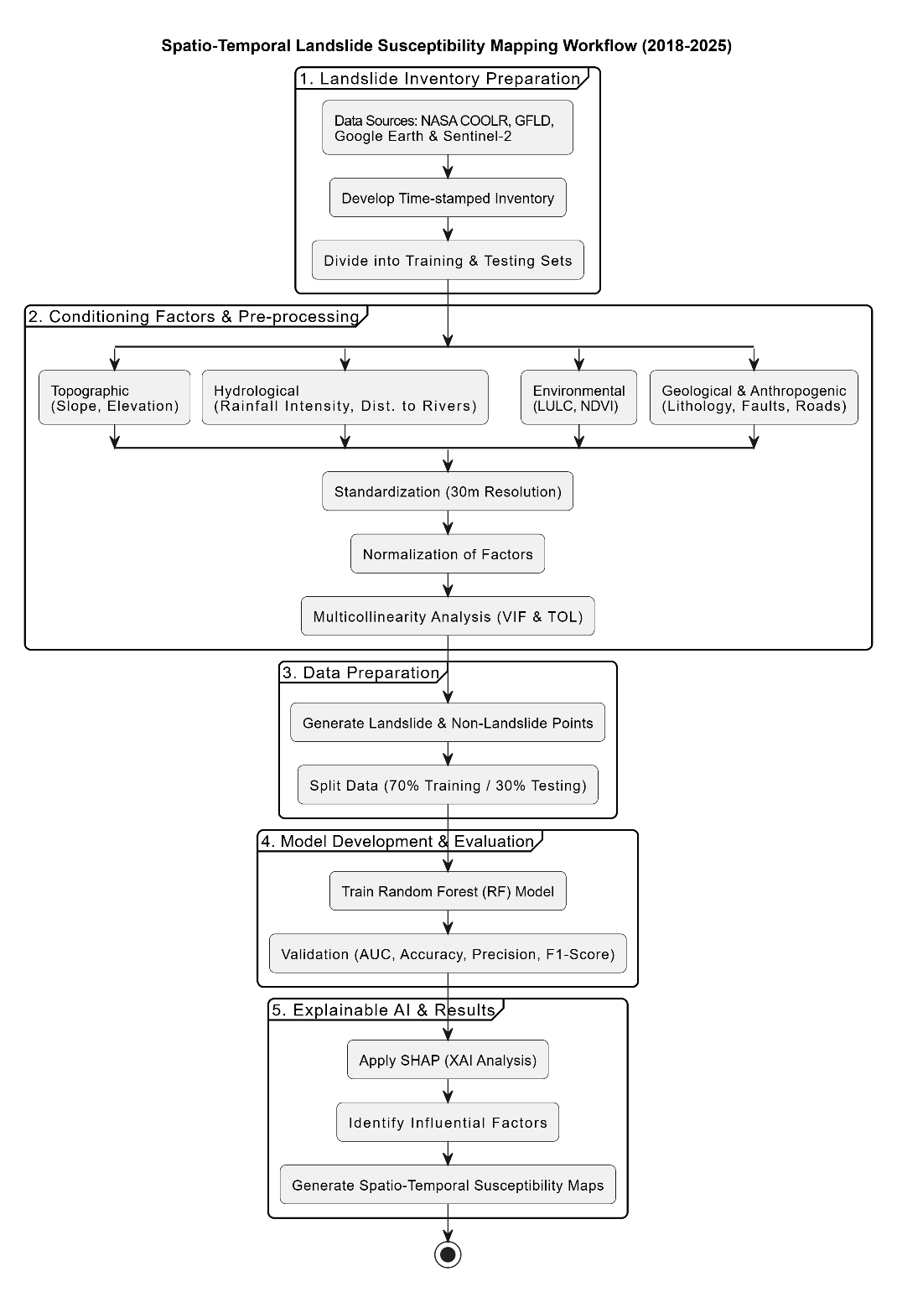

Expected Results
- Spatio-temporal landslide susceptibility maps for Gilgit District (2018–2025).
- Identification of the most influential landslide-triggering factors using SHAP.
- Interpretable Random Forest model for decision-makers.
- Scientifically sound outputs to support disaster risk reduction, infrastructure planning, and sustainable land-use management.

References
Abbas, F., Zhang, F., Ismail, M., Khan, G., Iqbal, J., Alrefaei, A. F., & Albeshr, M. F. (2023). Optimizing machine learning algorithms for landslide susceptibility mapping along the Karakoram Highway, Gilgit-Baltistan, Pakistan: A comparative study of baseline, Bayesian, and metaheuristic hyperparameter optimization techniques. Sensors, 23(15), 6843. https://doi.org/10.3390/s23156843
Akosah, S., Gratchev, I., Kim, D. H., & Ohn, S. Y. (2024). Application of artificial intelligence and remote sensing for landslide detection and prediction: A systematic review. Remote Sensing, 16(16), 2947. https://doi.org/10.3390/rs16162947
An, B., Zhang, Z., Xiong, S., Zhang, W., Yi, Y., Liu, Z., & Liu, C. (2024). Landslide susceptibility mapping based on ensemble learning in the Jiuzhaigou Region, Sichuan, China. Remote Sensing, 16(22), 4218. https://doi.org/10.3390/rs16224218
Chen, W., Pourghasemi, H. R., Kornejady, A., & Zhang, N. (2017). Landslide spatial modeling: Introducing new ensembles of ANN, MaxEnt, and SVM machine learning techniques. Geoderma, 305, 314–327. https://doi.org/10.1016/j.geoderma.2017.06.020
Gupta, A., et al. (2025). Landslide susceptibility along National Highway-7 in the Himalayas using random forest-based machine learning tool. Journal of Earth System Science, 134, 74.
Guria, R., Mishra, M., Roy, S. K., Silva, R. M., de Oliveira, G., & Santos, C. A. G. (2025). Machine learning-based spatiotemporal analysis for landslide susceptibility mapping in the Hindu Kush Himalayan region. Earth Systems and Environment. https://doi.org/10.1007/s41748-025-00683-2
Hussain, M. A., Chen, Z., Wang, R., Shah, S. U., Shoaib, M., Ali, N., & Ma, C. (2022). Landslide susceptibility mapping using machine learning algorithm. Civil Engineering Journal, 8, 209–224.
Hussain, M. A., Chen, Z., Wang, R., & Shoaib, M. (2021). PS-InSAR-based validated landslide susceptibility mapping along Karakoram Highway, Pakistan. Remote Sensing, 13(20), 4129. https://doi.org/10.3390/rs13204129
Inan, M. S. K., & Rahman, I. (2023). Explainable AI integrated feature selection for landslide susceptibility mapping using TreeSHAP. SN Computer Science, 4(5), 482. https://doi.org/10.1007/s42979-023-01931-1
Khaliq, A. H., Basharat, M., Riaz, M. T., Wani, S., Al-Ansari, N., Le, L. B., & Linh, N. T. T. (2023). Spatiotemporal landslide susceptibility mapping using machine learning models: A case study from district Hattian Bala, NW Himalaya, Pakistan. Ain Shams Engineering Journal, 14(3), 101907. https://doi.org/10.1016/j.asej.2022.101907
Kunwar, S., Khali, H., Praveenkumar, T. R., Meer, M. S., & Das, J. (2025). Integrating GIS and ensemble learning models to predict landslide-prone zones in Chamoli District, India. Discover Applied Sciences, 7(11), 1320.
Pradhan, B., Dikshit, A., Lee, S., & Kim, H. (2023). An explainable artificial intelligence (XAI) model for landslide susceptibility modeling. Applied Soft Computing, 142, 110324. https://doi.org/10.1016/j.asoc.2023.110324
Shahzad, N., Ding, X., & Abbas, S. (2022). A comparative assessment of machine learning models for landslide susceptibility mapping in the rugged terrain of northern Pakistan. Applied Sciences, 12(5), 2280. https://doi.org/10.3390/app12052280

